

Polio – almost gone, but far from forgotten
World Polio Day is an opportunity to remind Australia, and the world, that polio eradication is within our sights. It’s also a fitting time to remember that thousands of Australians are living with polio’s late effects.

While the virus may be a thing of the past in Australia, polio survivors want to remind you that “We’re Still Here!”

As part of World Polio Day, the Rotary Club of Heidelberg and the Rotary District 9790 Foundation team invites to join an online meeting, via Zoom, on Monday 25 October at 1.00 pm. The meeting will hear from Gillian Thomas and Stephanie Cantrill from Polio Australia on late effects of polio and the work of Polio Australia.
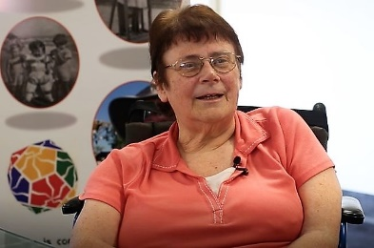
Gillian Thomas
President, Polio Australia
Gillian Thomas OAM is currently President of both Polio NSW and Polio Australia. She contracted polio as a baby in 1950 which resulted in both legs and one arm being paralysed. Nevertheless, she learnt to walk with the aid of callipers. With the onset of the late effects of polio some 30 years ago, her “good” right arm has become increasingly weak while her mobility has also considerably decreased. Gillian now uses a wheelchair – but says that she is enabled by it, not confined by it! Gillian has received recognition of her work for polio survivors being awarded an OAM in 2020.

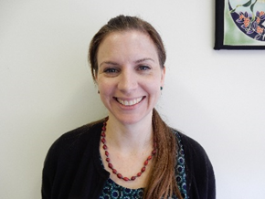
Stephanie Cantrill
Community Programs Manager, Polio Australia

Steph, an Occupational Therapist, has been working with Polio Australia since 2018. She lived and worked for a community development project in India for four years where she first met people with disability from polio. Steph’s role with Polio Australia is to provide information, resources and connection for the polio community across the country – which, due to the emergence of a different virus, has been entirely online or telephone-based since early 2020. Steph loves helping people access the information or health services they need to manage their condition as best they can.

ZOOM LOG IN before 1.00pm MONDAY 25 OCTOBER https://zoom.us/j/559962964?pwd=SVpTSVZ2RnhkVHNrQmJqN2NwUlU1Zz09
Or Meeting ID: 559 962 964 and Passcode: 9fQG9A


